In this lecture, The fifth part of the first module was covered. Which is “Conditional statements”

Conditional statements in python perform different actions based on some Boolean constraint or conditions also known as decision making conditions.

There are 4 types of conditional statements in Python.

* If statement
* If-Else statement
* Elif statement
* Nested If statement

**If statement:**

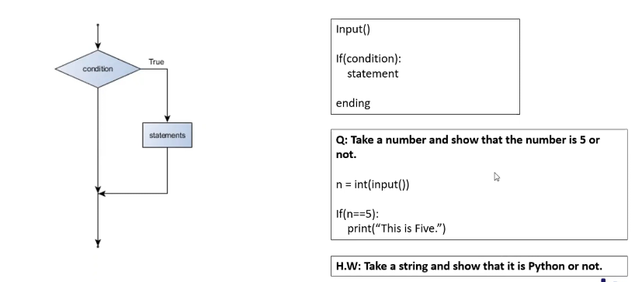

Here, The computer will make decisions based on a condition being true or not.

If true, Then it will execute a command/statement and if not true, It will not execute that command/statement.

In the example above, We take an integer as an input and we are checking if that integer is exactly **“5”**. If it is 5, It will print “**This is five**”. If not, It will simply ignore that command/statement.

**If-Else statement:**

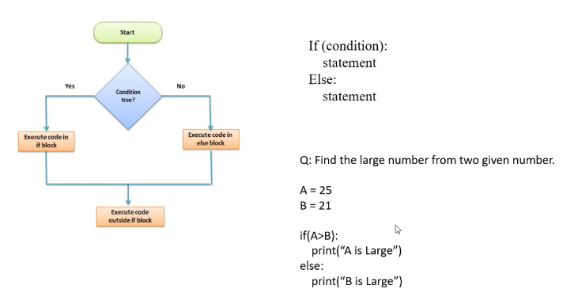

Here, The computer will make decisions based on a condition being true or not.

If true, Then it will execute a command/statement and if not true, It will execute some command/statement based on that If condition not being true

In the example above, We take two integers as inputs and we are checking if that integer “A” is greater than integer “B”. If it is greater, It will print “**A is large**”. If not, It will print “**B is large**”.

This 2 statements/commands are completely depending on this “IF” statement being true or not.

**Elif statement:**

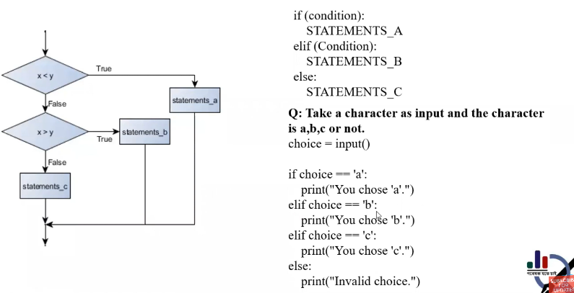

Here, The computer will make decisions based on a condition being true or not but there will be alternate conditions to that decision making and one single condition like the previous ones.

If true, Then it will execute a command/statement and if not true, It will check if it satisfies some other alternative conditions or not. Note that, There could be multiple numbers of alternative conditions. So, It will only execute the command/statement that satisfies the according condition.

The priority will always be the conditions that it encounters first.

In the example above, We take a string as inputs and we are checking if that string is “a”. If it is, It will print “**You chose a**”. If this isn’t true, It will check if that string is “b”. If it is, It will print “**You chose b**”. And, If even this isn’t true, It will check if that string is “c”. If it is, It will print “**You chose c**”

If none of them are true, It will print “**Invalid choice**”

**Note:** The first condition is always being prioritized the most.

**Nested if statement:**

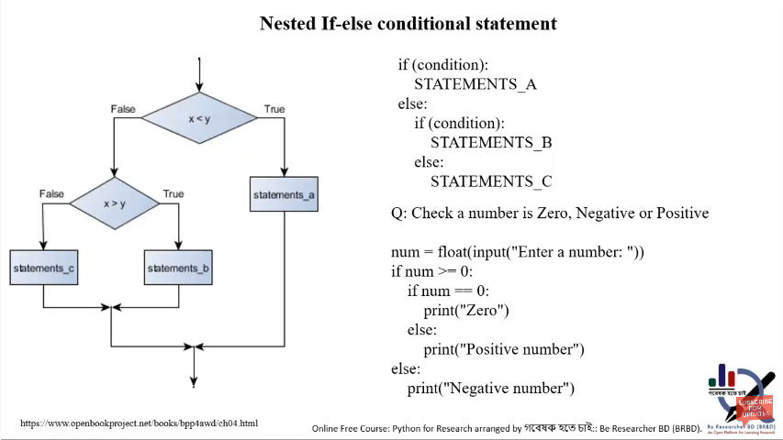

Here, There will be multiple if/if-else/ elif conditions inside another.

If true, Then it will execute a command/statement and if not true, It will check if it satisfies some other alternative conditions or not.If that is true, It will execute some commands/statements and if not, It will ignore or execute some other alternate commands/statements depending on what kind of condition is nested here.

In the example above, We take a float number as inputs and we are checking if that number is greater or equal than “0”. If it is greater than zero, We are checking if that number is exactly 0.

If that is also true, It will print “**Zero**”, Otherwise it will print **“Positive number”.**

If one of them are true, It will simply print **“Negative number”**

**Reference:**

* <http://guru99.com>
* <http://www.openbookproject.net>